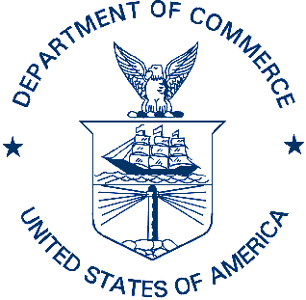UNITED STATES DEPARTMENT OF COMMERCE
National Oceanic and Atmospheric Administration
Alaska Fisheries Science Center
Ted Stevens Marine Research Institute
17109 Pt Lena Loop Road
Juneau AK, 99801

DRAFT Project (Cruise) Instructions

Date Submitted:
Platform: Charter F/V The Northwest Explorer
Project Number: 404 ABL (EMA); 127 RACE (RP)
Project Title: Gulf of Alaska Assessment
Project Dates: June 25, 2014 to September 4, 2014

Prepared by: ________________________ Dated: __________________
Wyatt Fournier
Research Fishery Biologist
Alaska Fisheries Science Center, EMA program

Approved by: ________________________ Dated: __________________

I. Overview
A. GOA Assessment Project: June 25 – September 4, 2014
This project will conduct fisheries oceanographic surveys in the eastern Gulf of Alaska and coastal Southeast Alaska. This project has two components: 1) Gulf of Alaska (GOA) survey sampling stations in federal waters up 100 miles offshore from the south end of Baranof Island to Kayak Island; 2) Southeast Coastal Monitoring (SECM) survey sampling stations in Auke Bay, the Upper Chatham Strait, Icy Strait and at Icy Point. The charter is 72 days total with 2 legs devoted to GOA (43 DAS), 3 legs devoted to SECM (24 DAS), and 5 port days.

B. Service Level Agreements: Awaiting funding approval

C. Operating Area: Gulf of Alaska

D. Summary of Objectives
The scientific objective of the survey is to assess Young of the Year (YOY) groundfish, salmonid species, plankton, and oceanographic conditions in the eastern GOA and coastal waters of Southeast Alaska. A chartered fishing vessel will be the sampling platform to provide information on species distribution, ecosystem structure, and marine productivity in response to changes in season, region, and climate. All objectives will be met by collecting data on fish, plankton, and oceanography at the same pre-determined master station locations (Figs. 1&2).

1) Observe epi-pelagic fish communities by sampling with rope trawl at the surface. Fish species of interest that will be retained from trawl are: arrowtooth flounder (Atheresthes stomias), rockfish species (Sebastes sp.), walleye pollock (Gadus chalcogrammus), Pacific cod (Gadus macrocephalus), sablefish (Anoplopoma fimbria), and Pacific salmon (Onchorhynchus sp.).

2) Collect electronic oceanographic data including CTD (Conductivity-temperature-depth) vertical profiles of temperature, salinity, light transmission, chlorophyll a fluorescence, dissolved oxygen, and photosynthetic available radiation (PAR).

3) Collect biological oceanographic samples (zooplankton and water) by oblique bongo tows and water sampling. Bongo array will have multiple mesh sizes to capture ichthyoplankton and zooplankton. The nisken bottle water sampler, attached to the CTD, will collect water samples at multiple depths for nutrients and chlorophyll.

E. Participating Institutions
Alaska Fisheries Science Center (ABL)
Ecosystem Monitoring and Assessment
17109 Pt Lena Loop Road, Juneau, AK 99801

Alaska Fisheries Science Center (RACE)
Recruitment Processes
7600 Sand Point Way N.E., Seattle, Washington 98115-0070

Pacific Marine Environmental Laboratory

F. Personnel/Science Party:
GOA
 | Name | Gender | Position | Organization
Leg 1a | Wyatt Fournier | M | Chief Scientist | EMA
July 5-15 | Casey Debenham | M | Fish biologist | EMA
 | Kevin Siwicke | M | Oceanographer | EMA
 | David Kachel | F | Oceanographer | PMEL
 | Colleen Harpold | F | Plankton | RP
Leg 1b | Jamal Moss | M | Chief Scientist | EMA
July 15-24 | Casey Debenham | M | Fish biologist | EMA
 | Kevin Siwicke | M | Oceanographer | EMA
 | Wess Strasburger | M | Plankton | EMA
 | Brian Beckman | M | Fish Biologist | NWFSC
Leg 2a | Wyatt Fournier | M | Chief Scientist | EMA
Aug 4-15 | Casey Debenham | M | Fish biologist | EMA
 | Wess Strasburger | M | Plankton | EMA
 | Kevin Siwicke | M | Oceanographer | EMA
 | Contract | F | Fish Biologist | EMA
Leg 2b | Wyatt Fou rnier | M | Chief Scientist | EMA
Aug 15-26 | Casey Debenham | M | Fish biologist | EMA
 | Kevin Siwicke | M | Oceanographer | EMA
 | Contract | F | Fish Biologist | EMA
 | Contract | F | Plankton | EMA
SECM
 | Name | Gender | Position | Organization
Leg 1 | Joe Orsi | M | Chief Scientist | EMA
June 26-July 3 | Emily Fergusson | F | Fish Biologist | RECA
 | Kris Cieciel | F | Oceanographer | EMA
 | Wess Strasburger | M | Plankton | EMA
 | Jamal Moss | M | Fish Biologist | EMA
Leg 2 | Emily Fergusson | F | Chief Scientist | RECA
July 26-Aug 2 | Joe Orsi | M | Fish Biologist | EMA
 | Michelle Morris | F | Fish Biologist | ADF&G
 | Sarah Ballard | F | Fish Biologist | RECA
 | TBD
 | TBD
Leg 3 | Joe Orsi | M | Chief Scientist | EMA
Aug 28-Sept 4 | Emily Fergusson | F | Fish Biologist | RECA
 | Steve Heinl | M | Fish Biologist | ADF&G
 | Sarah Ballard | F | Fish Biologist | RECA
 | TBD
 | TBD

G. Administrative
1. Points of Contact:
Wyatt Fournier (Chief Scientist)

NOAA – Fisheries, Auke Bay Laboratories
17109 Point Lena Loop Rd. Juneau, AK 99801
Ph: 907-789-6405 Email: Wyatt.Fournier@noaa.gov

Joe Orsi
NOAA – Fisheries, Auke Bay Laboratories
17109 Point Lena Loop Rd. Juneau, AK 99801
Ph: (907) 789-6034 Email Joe.Orsi@noaa.gov

Ed Farley
NOAA – Fisheries, Auke Bay Laboratories
17109 Point Lena Loop Rd. Juneau, AK 99801
Ph: (907) 789-6085 Email: Ed.Farley@noaa.gov
2. Licenses and Permits
This project will be conducted under the Blanket Scientific Research Permit (SRP) # 2014-8 issued by the U.S. on May 27, 2014 effective June, 25 - September 5, 2014. In addition, the State of Alaska Fish Resource Permit CF-14-031 has been granted and is effective February 5, 2014 to December 31, 2014.

II. Operations
A. Project Itinerary
June 25 Charter Begins in Juneau
June 26 Load SECM in am, depart in pm
June 27- July 2 SECM (leg 1) Survey Icy Straight, Icy Point, and Upper Chatham
July 3 Survey Auke Bay and unload SECM in pm
July 4 Port (Juneau)
July 5 Load GOA in am, depart in pm
July 6-14 GOA (leg 1a) Survey Southeast grid
July 15 Crew Change in Sitka
July 16-24 GOA (leg 1b) Survey Southeast grid, transit to Juneau
July 25 Port (Juneau) unload GOA
July 26 Load SECM in am, depart in pm
July 27- Aug 1 SECM (leg 2) Survey Icy Straight, Icy Point, and Upper Chatham
Aug 2 Survey Auke Bay and unload SECM in pm
Aug 3 Port (Juneau)
Aug 4 Load GOA in am, depart in pm
Aug 5-14 GOA (leg 2a) Survey Fairweather grounds
Aug 15 Crew Change in Yakutat
Aug 16-25 GOA (leg 2b) Survey Yakutat Bay to Kayak Island
Aug 26 Transit
Aug 27 Port (Juneau) unload GOA
Aug 28 Load SECM in am, depart in pm
Aug 29- Sept 3 SECM (leg 3) Survey Icy Straight, Icy Points, and Upper Chatham
Sept 4 Survey Auke Bay and unload SECM in pm *End of Charter

B. Staging and Destaging
All equipment necessary for this project will be at the NOAA Subport in downtown Juneau, Alaska. All loading and unloading will take place at this location.

C. Underway Operations
GOA
There are 38 designated sampling days and 4 stations are expected to be occupied per day resulting in a maximum of 152 stations occupied. The first leg will begin at the southern most transect and the survey will continue to the north (Figure 1).
Daily Order of Operations:
-CTD cast
-Bongo tow
-Surface trawl

Oceanography
CTD casts will occur at each station. Instruments added to the CTD include a PAR sensor, fluorometer, transmissometer, and dissolved oxygen sensors. The casts will be to “bottom” (5-10 m from bottom) or 200 m (if bottom depths are > 200 m). Water samples will be taken at four depths (0, 20, 40, and “bottom”), nutrients and chlorophylls will be taken at all four depths. Salinity will be sampled daily alternating between surface and bottom.
Anticipated sampling:
CTD: 152 casts
Nutrients & Chlorophyll: 608 samples
Salinity: 38 samples

Zooplankton collection
A bongo plankton net tow will be conducted to collect zooplankton at stations maintaining a 20x20 mile sampling distribution. The standard gear for plankton sampling will be a 60-cm bongo (SOI 3.2.2) with a 505 and a 333micron mesh nets paired with a 20cm bongo with a 125-micron mesh net. A FastCat will be mounted above the bongo to provide depth, temperature, and salinity data. Tows will be to 200 meters or 10 meters off the bottom where water depth is shallower. The samples collected from the 20-cm and 60-cm bongos will be preserved in 1.8% formaldehyde, buffered with sodium borate.
Anticipated sampling:
505, 333, and 125 micron mesh nets: 152 samples each

Surface trawling
A CanTrawl 400-601 rope trawl will be deployed at each station with spectra bridle and 5 meter alloy NETS doors. Two 50-kg chain-link weights will be added to the corners of the foot rope as the trawl is deployed to maximize fishing depth. To keep the trawl head rope fishing at the surface, two clusters of three A-4 Polyform buoys (inflated to 0.75 m diameter and encased in knotted mesh bags) will be clipped on the opposing corner wingtips of the head rope prior to deployment and the ship provided Simrad FS-20 3rd wire net sounder will be attached. An average of 4 surface trawl hauls is anticipated per day. Surface trawl duration will be 30 minutes, beginning when the doors are fully deployed.

Marine fish and salmon collection:
All species caught will have lengths and weights recorded for the first 50 individuals. In the case that an individual fish is too small for an accurate weight, bulk weights will be recorded.

At each station:
Sub-samples of whole YOY walleye pollock (n=8), Pacific cod (n=8), sablefish (n=20), and arrowtooth flounder (n=8) will be individually bagged and tagged and stored in the -80 (or -40) freezer for energetic and diet analysis. Up to n=50 individuals of “POP type” YOY rockfish will be sub-sampled for energetic and RNA/DNA analysis, individually bagged and tagged to be stored at -80 (or -40). Individuals will be combined at each station for a composited analysis on energetics and stomach contents.
Juvenile Chinook salmon will be sub-sampled for energetic analysis (n=5) and diets, otoliths, and genetics (n=10). Any additional juvenile Chinook with CWT detected or adipose fin clipped will also be retained. Juvenile chum and pink salmon will be sub-sampled for energetic analysis (n=2) and diets and genetics (n=8). Whole individuals and tissue samples will be stored in the ship’s provided chest freezers. Stomachs will be removed from the first 5 juvenile coho salmon for diet analysis and preserved in 10% formalin. Adult Chinook salmon snouts, muscle tissue, otoliths and scales will be collected when CWT is detected or fin clip observed. The first ten adult Chinook, pink, and coho salmon will have their stomachs removed, and stored in chest freezers. Diet analysis will be done by combining the stomach contents of the individuals at each station for a composited analysis.

SECM
Each leg will repeatedly sample 13 stations in the Auke Bay, Chatham Strait, Icy Strait and Icy Point localities (Figure 2).
Order of Operations:
-CTD
- Zooplankton tow
- Surface trawl

Oceanography

Stations will be sampled between 1 and 4 times per survey leg. The first time a station is sampled, “Full” oceanography sampling will occur. For the remaining times a station is sampled, “Lite” oceanography sampling will occur.

Full: CTD casts will occur once at each station during the first sampling occurrence at each station (n = 13). Instruments added to the CTD include a PAR sensor, fluorometer, transmissometer, and dissolved oxygen sensors. The casts will be to “bottom” (5-10 m from bottom) or 200 m (if bottom depths are > 200 m). Water samples will be taken at four depths (0, 20, 40, and “bottom”), nutrients and chlorophylls will be taken at all four depths. Salinity will be sampled daily alternating between surface and bottom.
Anticipated sampling:
CTD: 39 casts
Nutrients & Chlorophyll: 78 samples
Salinity: 21 samples

Lite: CTD casts will occur during replicate visits to a station. A smaller CTD unit will be used for this sampling and will only be deployed to 50m. No water samples or salinity samples will be collected.
Anticipated sampling:
CTD: 15 casts

Zooplankton collection

After each FULL CTD sampling event, zooplankton will be collected with 2 net types, a NORPAC and a bongo net. This will be conducted once at each station during each leg.
NORPAC: One shallow (20-m) vertical Norpac tow will be made prior to each bongo tow using a 50-cm, single ring frame with 243-µm mesh net.
Bongo: One double oblique bongo tow will be made after each NORPAC tow. The bongo net system consists of a 60-cm tandem frame with 505 and 333µm mesh nets paired with a 20cm tandem frame with 125µm mesh nets. A FastCat will be mounted above the bongo to provide depth, temperature, and salinity data. Tows will be deployed to 200 meters or 20 meters off the bottom. The samples collected from the 20-cm and 60-cm bongos will be preserved in a 5% formalin-seawater solution.

Anticipated sampling:
NORPAC: 39
Bongo: 505, 333, and 125µm nets: 39 samples each

Surface trawling
Surface trawling will be conducted using a Nordic 264 rope trawl modified to fish the surface water directly astern of the trawl vessel. A pair of 3-m foam-filled Lite trawl doors, each weighing 544 kg (91 kg submerged), will be used to spread the trawl open. Two 50-kg chain-link weights will be added to the corners of the foot rope as the trawl is deployed to maximize fishing depth. To keep the trawl head rope fishing at the surface, two clusters of three A-4 Polyform buoys (inflated to 0.75 m diameter and encased in knotted mesh bags) will be clipped on the opposing corner wingtips of the head rope and the ship provided Simrad FS-20 3rd wire net sounder will be attached into a mesh kite pocket in the center of the head rope to monitor the net spread. Two AQUAmark 100/210 pingers (20-160 kHz, 145-150 dB) or Fumunda F10 (10 kHz, 32 dB) will attached to the corners of the head rope to deter porpoise interactions. The trawl will be fished with approximately 150 m of 1.6-cm wire main warp attached to each door.
For each haul, the trawl will be fished across a station for 20 min at approximately 1.5 m/sec (3 knots) to cover 1.9 km (1.0 nautical mile). Station coordinates will be targeted as the midpoint of the trawl haul.

Marine fish collection:
Salmon: After each trawl haul, the fish will be separated from the jellyfish, identified, enumerated, measured, labeled, individually bagged, and frozen. All fish and squid will be measured to the nearest mm fork length (FL) or mantle length. In the instance of a very large catche, all fish will be counted, a subsample of each species (≤ 100) will be processed, and excess fish will be discarded. All Chinook and coho salmon will be examined for missing adipose fins an indication of the presence of implanted CWTs. All frozen fish will be analyzed in the laboratory for weight and their otoliths will be removed to identify stock of origin. A subset of these fish will be analyzed for energy density and diet composition.

Salmon potential predators: Potential predators of juvenile salmon from each haul will be identified, measured (FL, mm), weighed (g), and have their stomach contents examined onboard the vessel.

Non-salmon species: All non-salmon fishes and squid will be identified, enumerated, measured, and returned to the water.

Sample Processing Plan

Physical oceanography to be processed at PMEL (number of samples)
Physical Oceanography | GOA | SECM
CTD | 136 | 39
Nutrients  Salinity | 544  38 | 78  21
Biological Oceanography to be processed at Poland Center (number of samples)
Zooplankton* | GOA | SECM
505 | 136 | 39
333 | 136 | 39
125  TOTAL | 136  408 | 39  117
*we do not plan to process samples for ichthyoplankton

Fish Energetics, Diet, and RNA/DNA to be processed in RECA/FEDZ lab (max #)
Fish Energetics |  | GOA |  |  | SECM
Walleye Pollock |  | 60 |  |  | 0
Pacific Cod |  | 40 |  |  | 0
Sablefish |  | 40 |  |  | 0
Arrowtooth |  | 40 |  |  | 0
Rockfish |  | 60 |  |  | 0
Juv Chinook |  | 100 |  |  | 30
Juv Chum |  | 100 |  |  | 30
Juv Pink |  | 60 |  |  | 30
Juv Sockeye  Juv Coho  TOTAL |  | 0  0  500 |  |  | 30  30  150
Fish Diet | GOA |  | SECM
Walleye Pollock | 60 |  | 0
Pacific Cod | 40 |  | 0
Sablefish | 40 |  | 0
Arrowtooth | 40 |  | 0
Rockfish | 60 |  | 0
Juv Chinook | 300 |  | 30
Juv Chum | 300 |  | 30
Juv Pink | 200 |  | 30
Juv Coho  Juv Sockeye | 100  0 |  | 30  30
TOTAL | 1140 |  | 150
Fish RNA/DNA | GOA |  |  | SECM
Rockfish  Walleye Pollock  Pacific Cod  TOTAL | 400  400  200  1000 |  |  | 0  0  0  0

D. Dive Plan N/A

E. Applicable Restrictions
Conditions that could preclude normal operations would be poor weather and equipment failure. Poor weather would be waited out in a sheltered area until operations could be resumed and modifications would be made to the sampling grid. Equipment failure would have to be addressed immediately for the project to continue.

III. Equipment

Trawling Equipment | Quant. | Vessel | Proj
Cantrawl 400/601 with accessories | 2 |  | X
Nordic 264 rope trawl  60-meter spectra bridals and hardware | 2  2 |  | X  X
40 meter spectra bridle  5-meter trawl doors | 2  1 |  | X  X
3-meter trawl doors | 2 |  | X
3rd wire net sonar | 1 | X

Fish Sampling Equipment | Quant. | Vessel | Proj
Catch sorting table | 1 |  | X
Marel 60 kg scale (with calib. Wts.) | 2 |  | X
Marel 6 kg scale (with calib. Wts.) | 2 |  | X
Fish measuring boards | 5 |  | X
Fish sorting containers | 20 |  | X
Totes (4 x 4 x 3 ft.) | 1 |  | X
Stainless steel fish tables | 2 |  | X
Basket weight table for 60 kg scale | 1 |  | X
Fish baskets | 20 |  | X

Zooplankton and Ichthyoplankton Equipment | Quant. | Vessel | Proj
Bongo net with accessories | 2 sets |  | X
FastCat | 2 |  | X
Flowmeters | 6 |  | X
Neuston net with accessories | 1 |  | X

Oceanographic Sampling Equipment | Quant. |  | Vessel |  | Proj
CTD SBE 25 CTD (on water sampler) | 1 |  |  |  | X
SBE 25 CTD with aux sensors (backup CTD) | 1 |  |  |  | X
fluorometer and beam transmission sensors | 1 |  |  |  | X
LICor PAR sensor | 1 |  |  |  | X
SBE 43 dissolved oxygen sensor | 2 |  |  |  | X
Niskin Bottles (5 L) | 6 |  |  |  | X
CTD carousel w/ real time bottle fire | 1 |  |  |  | X
PC for GPS and CTD | 2 |  |  |  | X
Vacuum manifold and pump | 2 |  |  |  | X
Oceanographic Equipment & Supplies |  | Quant. |  | Vessel |  | Proj
Supercold freezer (-80C) |  | 1 |  |  |  | X
Supercold freezer (-40C) |  | 1 |  |  |  | X
Chest freezer (-20C) |  | 3 |  | X
Filter racks and pumps |  | 1 |  |  |  | X
Hazmat storage cabinets |  | 0 |  |  |  | X
Microscopes (dissecting) |  | 1 |  |  |  | X
Oceanographic sampling tables |  | 1 |  |  |  | X
Water collection bottles/basket set |  | 1 |  |  |  | X
Totes (4 x 4 x 3 ft.) |  | 2 |  |  |  | X
Biological supplies (misc.)  Oceanographic Winch |  | *  1 |  |  |  | X  X

Oceanographic Chemicals | Quant. | Vessel | Proj
Formalin (5 L) | 4 |  | X
Sodium bicarbonate-13C (100 ml) | 3 |  | X
HCl (0.1 N, < 1%) (L) | 1 |  | X
Formalin spill kit | 1 |  | X
Sodium borate (borax) (L) | 1 |  | X

Computing Equipment | Quant. | Vessel | Proj
Laptops | 2 |  | X

V. Additional Projects
A. Supplementary (“Piggyback”) Projects N/A
B. Ancillary Projects
Ancillary projects are secondary to the objectives of the cruise and should be treated as additional investigations. An ancillary project does not have representation aboard and is accomplished by the ship's personnel.

VI. Disposition of Data and Reports
A. Data Responsibilities
B. Pre and Post Project Meeting
Prior to departure, the Chief Scientist will conduct a meeting of the scientific party to train them in sample collection and inform them of project objectives. Some vessel protocols, e.g., meals, watches, etiquette, etc. will be presented by the ship’s Operations Officer.
Post-Project Meeting: Upon completion of the project, a meeting will be held to address concerns regarding safety, efficiency, and suggestions for improvements for future projects.

VII. Miscellaneous
A. Meals and Berthing
Meals and berthing are required for up to 6 scientists. Meals will be served 3 times daily beginning with schedule determined by Chief scientist and cook. Special dietary requirements for scientific participants will be made available to the ship’s cook at least seven days prior to the survey.
Berthing requirements, including number and gender of the scientific party, will be provided to the ship by the Chief Scientist. The Chief Scientist and Captain will work together on a detailed berthing plan to accommodate the gender mix of the scientific party taking into consideration the current make-up of the ship’s complement.

B. Medical Forms and Emergency Contacts

C. Shipboard Safety
Wearing open-toed footwear or shoes that do not completely enclose the foot (such as sandals or clogs) outside of private berthing areas is not permitted. Steel-toed shoes are required to participate in any work dealing with suspended loads, including CTD deployments and recovery. Hard hats are also required when working with suspended loads. Personal floatation will be worn at all times while working on deck.

D. Communications
Because it is sometimes necessary for the scientific staff to communicate with other research vessels, commercial vessels, and shore-based NOAA facilities, the Chief Scientist or his designee may request the use of radio transceivers aboard the vessel.
Communication with the commercial fishing fleet provides information that allows scientists to direct their efforts more efficiently. The bridge will notify the Chief Scientist or his designee whenever such communication is received.

E. Figures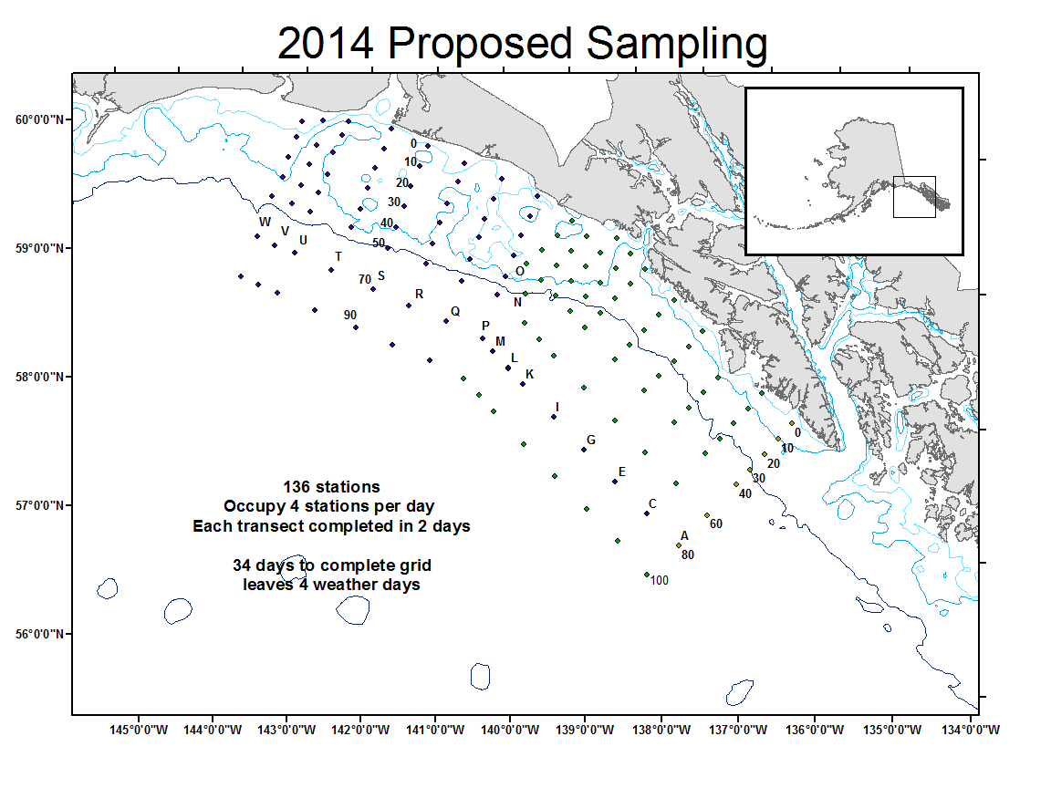
Figure 1 —Stations scheduled in the Gulf of Alaska component of survey
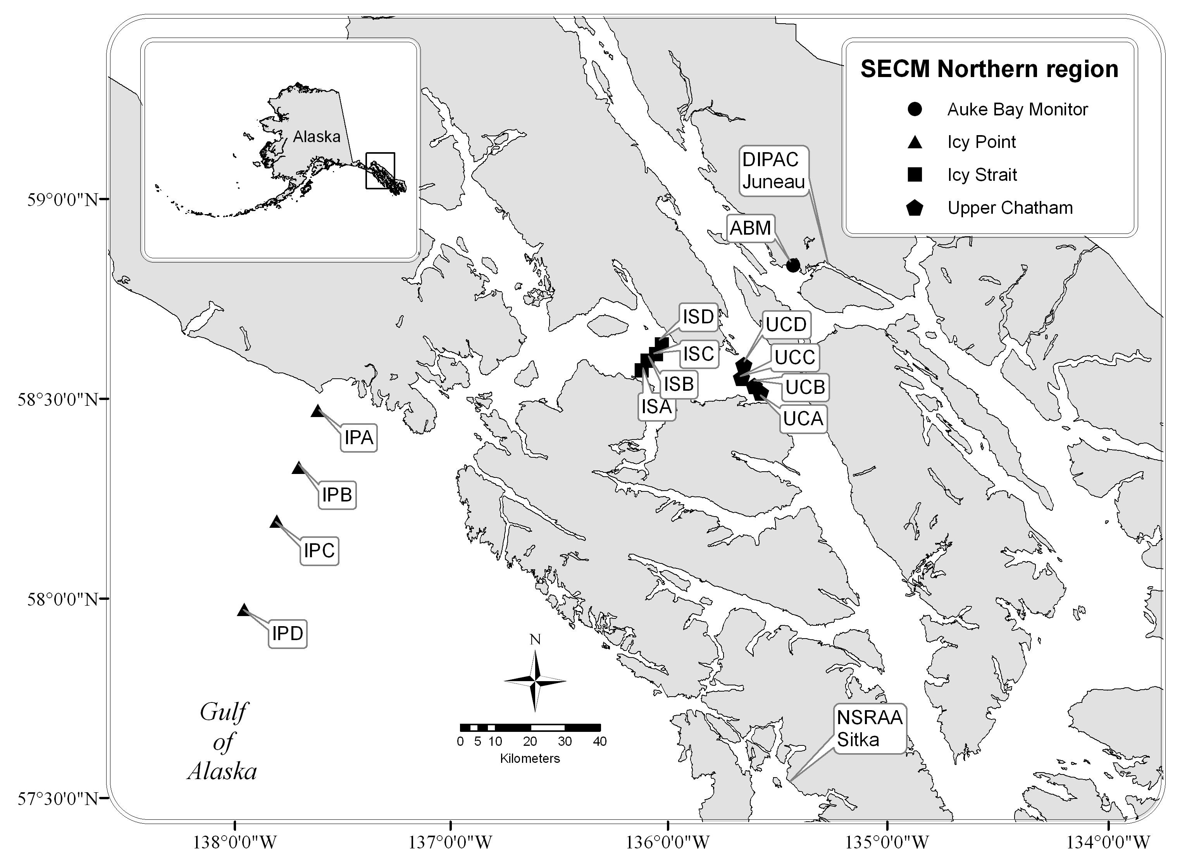
Figure 2.—Stations scheduled to be sampled during SECM component of survey

